**Developing Poker Odd Calculator App in Microsoft PowerApps**

**Introduction**In this article, we are going to see how to Develop Poker Odd Calculator App in Microsoft PowerApps.

In PowerApps, we can Add ‘N’ no of Control.

Follow the below steps to develop the Poker Odd Calculator App in PowerApps:

**Step 1: Log into the PowerApps**

we need Microsoft related organization’s Office 365 ID or (MSDN, Microsoft, Skype, Office 365 etc.,), to login with it.

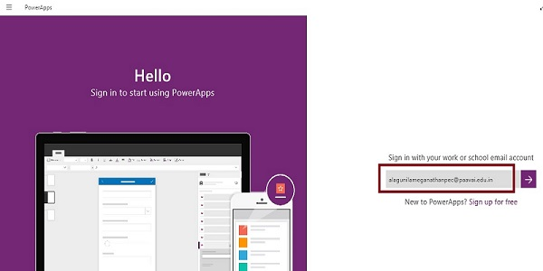

**Step 2: Create a New App in PowerApp**

After Login, we can see the Dashboard. There we click on the **New** button.

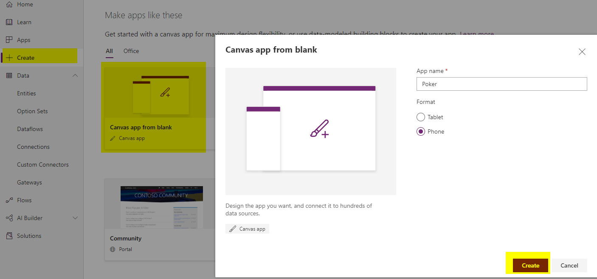

**Step 4: Designing the App**

Now, let's start to designing the App. In left side we can see the **Individual Screens** for adding our data. In Right side we see the List of **Layouts**. In the Top we see the formula bar. There you seen the **Properties** of the screen what you select. In the Right Side we see the Add Data Source to add the External data Source.

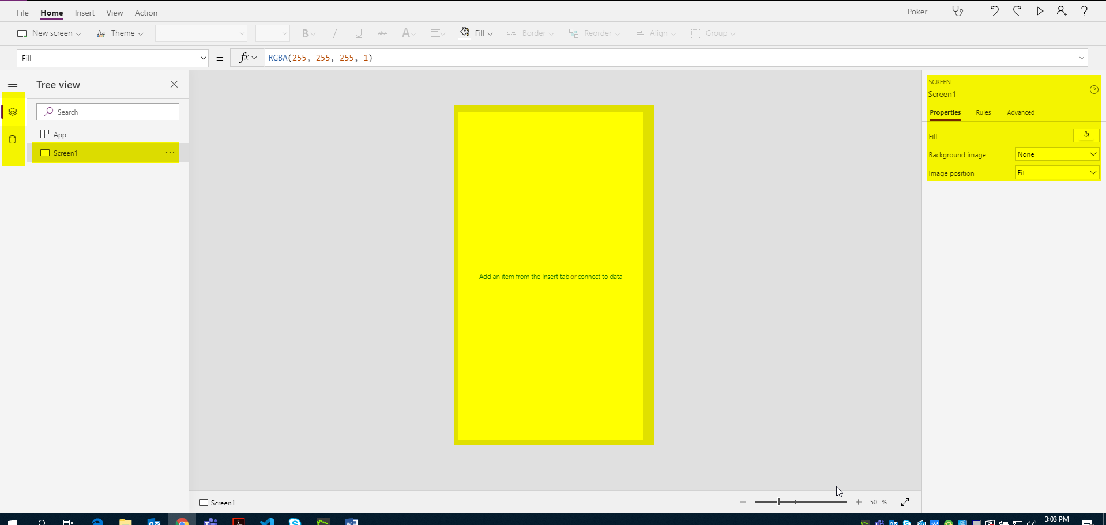

**Step 5: Add one more screen and name it as “Registration_1”**

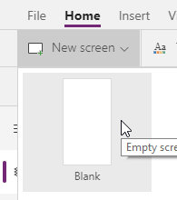

**Step 5: Drag and Drop the Pen Input Control**

1. **Go to the Insert menu then Controls and Drag the text Input control and Label controls.**

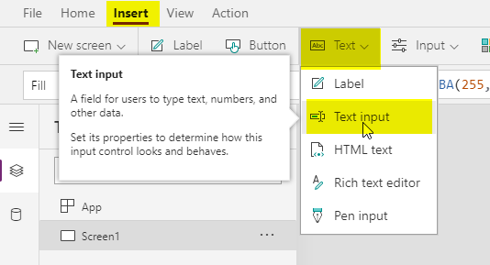

1. **Drop the Image, Text box and Label control on the Screen. And design as follow.**

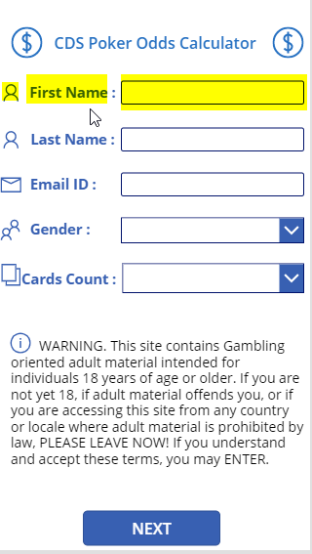

1. **Rename the Controls**

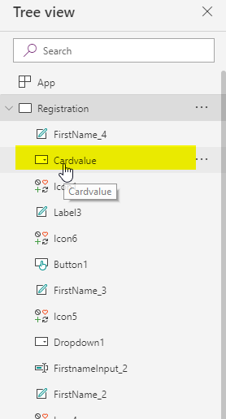

**Step 7: Drag and Drop the Button Control Tool**

The Button Control is used for saving, submitting data to api , navigation etc.

1. **Go to the Insert Menu and Drag the Button Control.**

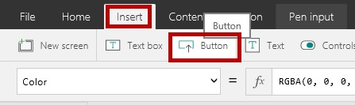

1. **Drag the Button control to the screen.**

Place it in the Screen and change the name to Next

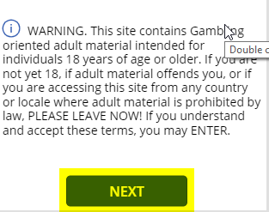

1. **Add the Coding**

Now **Select the Button Control** and add the coding to the **OnSelect Event**.



**Coding:**

Navigate (Registration_1, ScreenTransition.CoverRight)

**Creating custom connection to calculate probability.**

**In the power apps portal select the Data🡺 Custom Connectors🡺 New custom connector 🡺 Import a Postman collection.**

1. **1** 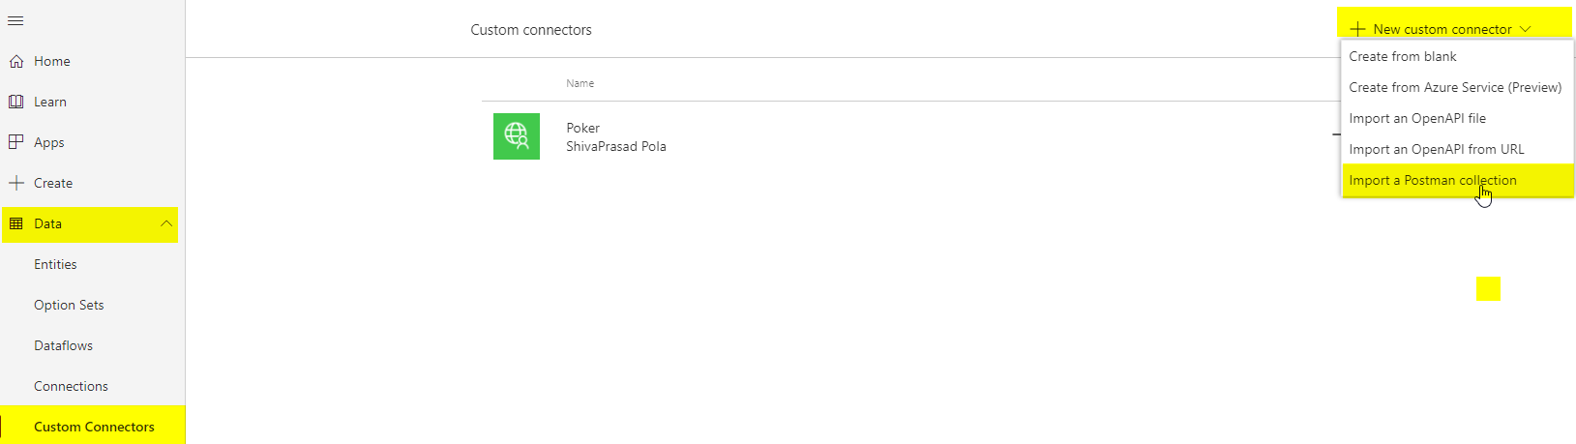

Add the jsonfile “powerapps.postman_collection.json” which is part of Pre- Requisites

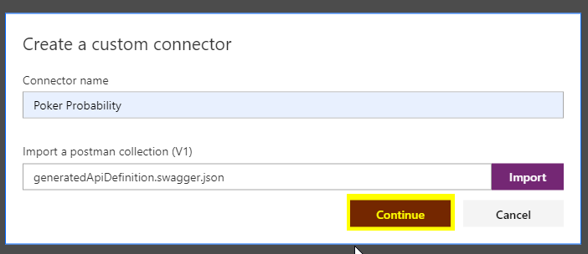

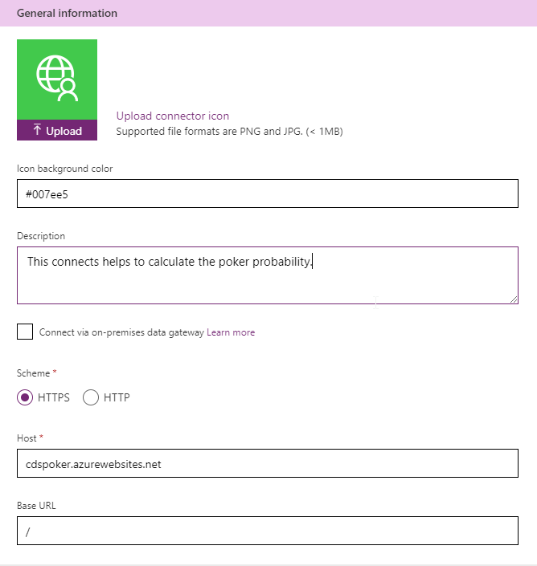

next

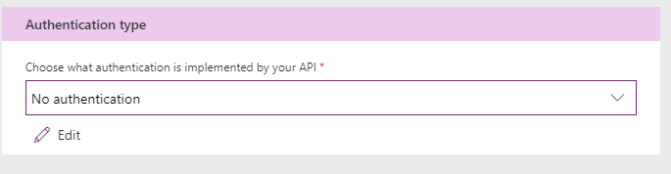

Next:

Add following json to body field:

[

{

"SLNO": 1,

"CardDetails": "Seven of Clubs"

},

{

"SLNO": 2,

"CardDetails": "King of Hearts"

},

{

"SLNO": 3,

"CardDetails": "Queen of Diamonds"

},

{

"SLNO": 4,

"CardDetails": "Queen of Clubs"

},

{

"SLNO": 5,

"CardDetails": "Queen of Diamonds"

}

]

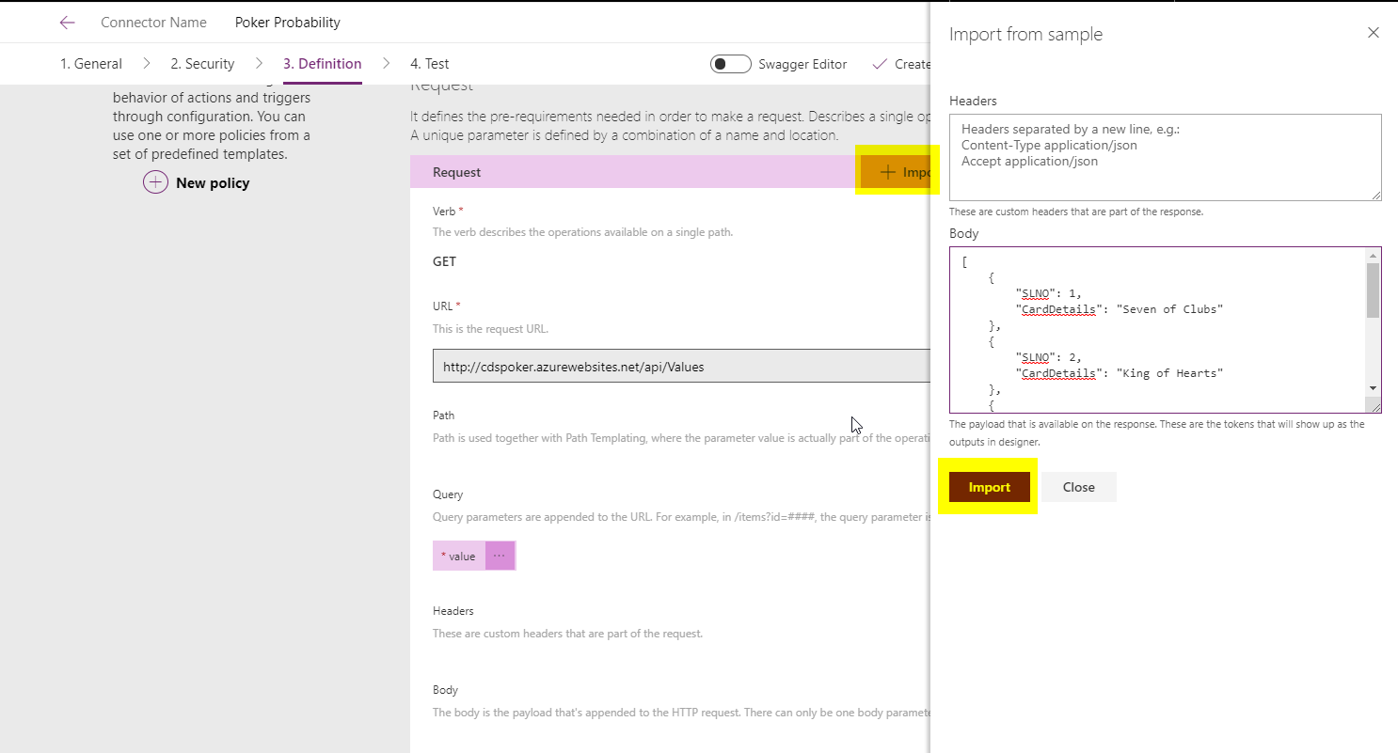

Repeat above steps for Get Probability post request with below json body:

[

{

"SLNO": "1",

"CardType": "High Card:",

"CardValue": "0 %"

},

{

"SLNO": "2",

"CardType": "Pair:",

"CardValue": "51.72 %"

},

{

"SLNO": "3",

"CardType": "Two Pair:",

"CardValue": "37.58 %"

},

{

"SLNO": "4",

"CardType": "Three of a Kind:",

"CardValue": "6.65 %"

},

{

"SLNO": "5",

"CardType": "Straight:",

"CardValue": "1.46 %"

},

{

"SLNO": "6",

"CardType": "Flush:",

"CardValue": "0 %"

},

{

"SLNO": "7",

"CardType": "Full House:",

"CardValue": "2.5 %"

},

{

"SLNO": "8",

"CardType": "Four of a Kind:",

"CardValue": "0.09 %"

},

{

"SLNO": "9",

"CardType": "Straight Flush:",

"CardValue": "0 %"

},

{

"SLNO": "10",

"CardType": "Royal Flush:",

"CardValue": "0 %"

}

]

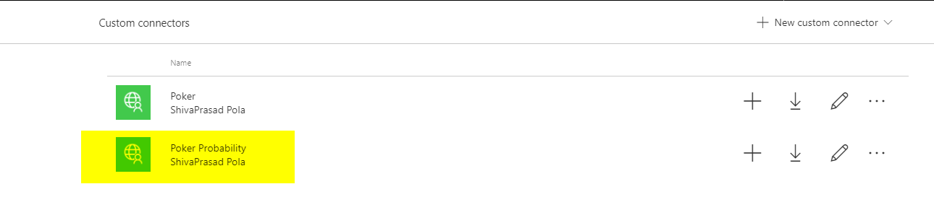

Navigate to screen “Registration_1” add data source

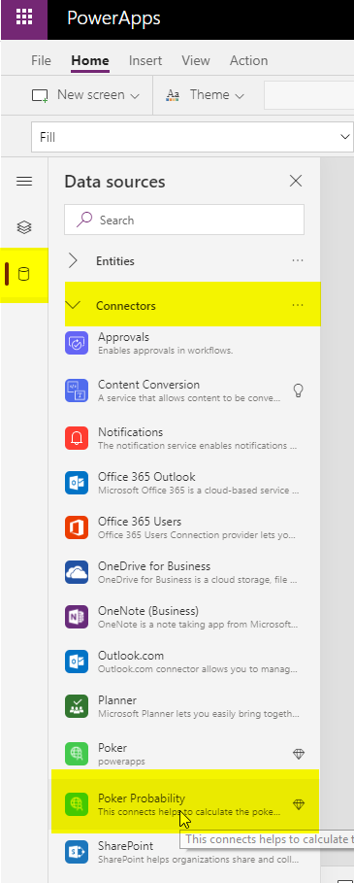

Once you add the data source a new section will create with name “In your App”

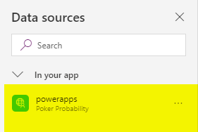

Navigate to screen 2 “Registration_1” as design as follow, Add button and table controls.

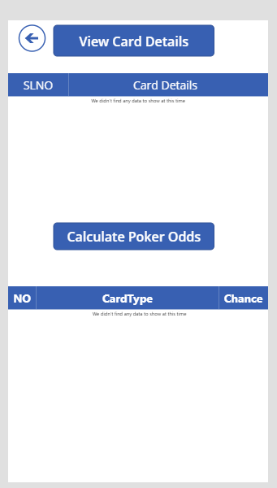

Save the power app and publish

Run the power app by clicking on the run button which is present in the top right corner



Fill the form as follow

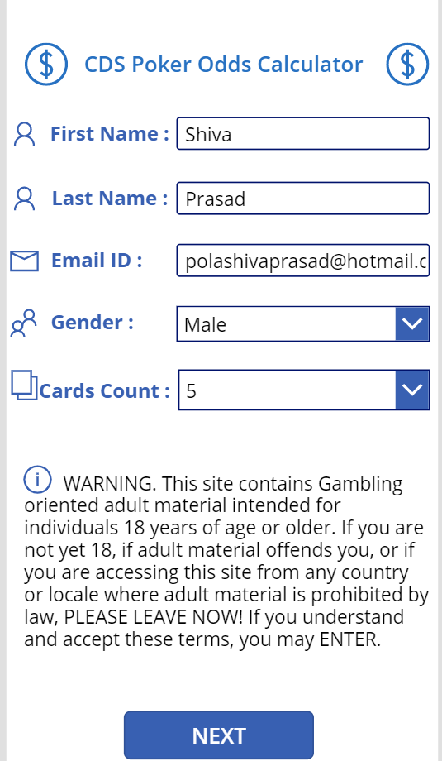

Click on next button then click on View card details it will display your cards:

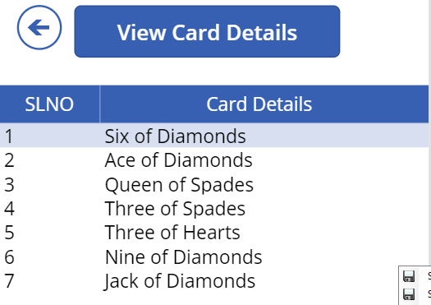

Now we need to calculate the poker Odds for above cards click on Calculate poker odds button

